CSI-2 RX Unpacker Functional Design Specifications
  - Design and Implementation of CSI Controller IP
  - Version 4.0.1

  - Block Owner
Hana Samy Ahmed
  - Authors
Hana Samy Ahmed
…

This Page is left Blank Intentionally

Table of Contents
1 Table of Contents 1
2 Revision History 2
3 Overview 3
4 Operation and Description 3
4.1 Digital Interface 3
4.1.1 Parameters Names 3
4.1.2 Ports Names 3
4.2 Functional Description 3
4.3 Block Diagram 3
4.4 Timing Diagram 3
4.5 Verification Requirements 3

Revision History
Version | Date | Author(s) | Revision Notes | Owner Approval
1 | 31-1-2026 | Hana Samy

Overview
The CSI-2 RX Unpacker is the first processing stage in the CSI-2 Receiver Data Path. It receives a raw, valid byte stream from the CSI-2 Depacketizer (D-PHY interface) and reconstructs the original parallel pixel data.
This block operates entirely on the high-speed i_byte_clk. It supports dynamic "Reverse Gearbox" operations to unpack multi-byte pixel formats (like RGB888 and RAW10) back into a native pixel bus. Its output is designed to be fed directly into an Asynchronous FIFO for clock domain crossing.

Operation and Description

Digital Interface

Parameters Names
Parameter Name | Default | Description
MAX_PIXEL_WIDTH | 24 | Maximum width of the reconstructed pixel (e.g., 24 for RGB888, 10 for RAW10).

Ports Names
Port Name | Port Width | Port Type | Description
Clocks and Resets
i_byte_clk | 1 | Input | High-speed MIPI Byte Clock.
i_rst_n | 1 | Input | Active-low asynchronous reset.
Configuration
i_cfg_data_type | 6 | Input | MIPI Data Type (DT) code. Configures the unpacking ratio.
Byte Input Interface (From Depacketizer)
i_rx_data | 8 | Input | Incoming payload byte stream.
i_rx_valid | 1 | Input | Valid flag for input byte.
i_rx_packet_done | 1 | Input | Indicates the last byte of the current line (Payload End).
i_rx_frame_start | 1 | Input | Single-cycle pulse indicating Start of Frame (from FS Packet).
Native Output Interface (To Async FIFO)
o_native_data | WIDTH | Output | Reconstructed Parallel Pixel Data.
o_native_valid | 1 | Output | Valid flag for the output pixel.
o_native_sof | 1 | Output | Start of Frame marker (aligned with the first valid pixel of the frame).
o_native_eol | 1 | Output | End of Line marker (aligned with the last valid pixel of the line).

Functional Description
The block functions as a configurable deserializer. It implements the inverse logic of the "Pixel-to-Byte Converter" described in the TX specification.
1. Dynamic Unpacking Logic
The state machine behavior changes based on i_cfg_data_type:
- Mode A: Byte Accumulation (RGB888, YUV422)
  - Logic: Accumulates N bytes to form 1 Pixel.
  - Example (RGB888 - 1:3 Ratio):
    - Cycles 1-2: The block receives and stores Byte 0 (Red) and Byte 1 (Green). o_native_valid is LOW.
    - Cycle 3: The block receives Byte 2 (Blue).
    - Output: It concatenates {Byte0, Byte1, Byte2} and asserts o_native_valid for one cycle.
  - Output Rate: 1 Pixel every 3 Clocks (assuming continuous input).
- Mode B: Reverse Gearbox (RAW10)
  - Logic: Unpacks 5 Bytes into 4 Pixels (Reverse of TX Mode B ).
  - Latency Phase (Cycles 1-5):
    - The block receives 4 bytes (MSBs of Pixels 1-4) and finally the 5th byte (Aggregated LSBs).
    - During these 5 input cycles, the block buffers the data.
  - Reconstruction Phase:
    - Once the 5th byte is latched, the block has all the data for 4 pixels.
    - It extracts the LSB pairs (Bits 1:0, 3:2, 5:4, 7:6) from Byte 5 and merges them with the stored MSBs.
  - Burst Output:
    - To match the single-pixel output bus width, the block bursts the 4 pixels out sequentially over the next 4 clock cycles (while the next group of bytes is arriving).
  - Output Rate: 4 Pixels every 5 Clocks.
2. Marker Propagation
- Start of Frame (SOF): The block latches the i_rx_frame_start pulse. When the very first pixel of the frame is fully reconstructed and o_native_valid goes High, o_native_sof is asserted High for that same cycle.
- End of Line (EOL): When i_rx_packet_done is detected on the input (coincident with the last byte), the block tags the last pixel currently being reconstructed. When that last pixel is finally output, o_native_eol is asserted.

Block Diagram
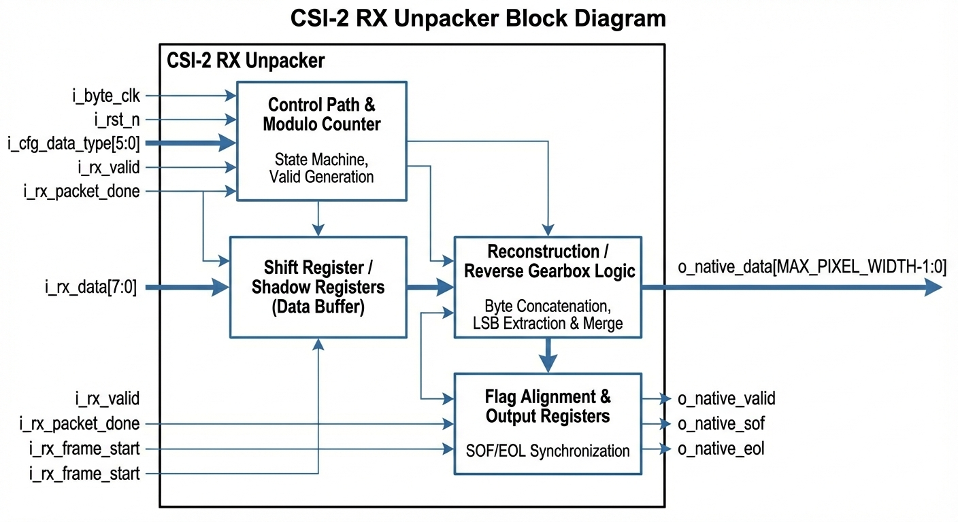

Timing Diagram
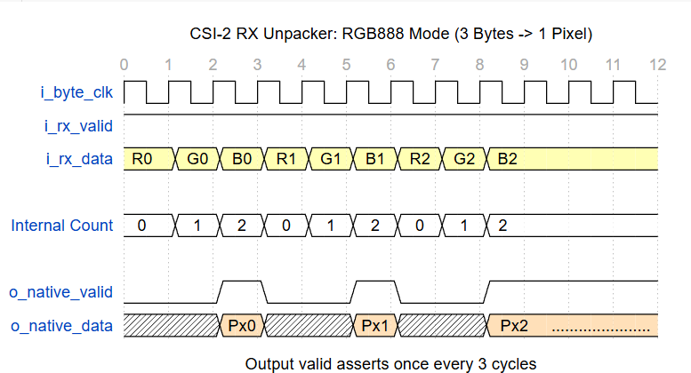
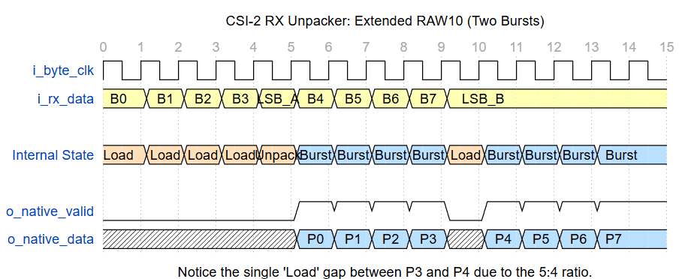

Verification Requirements
- Format Reconstruction: Verify that RGB888 inputs (R-G-B sequence) result in a single {R,G,B} output word.
- RAW10 LSB Mapping: Verify that the LSBs from the 5th byte are correctly assigned to Pixels 1, 2, 3, and 4 respectively.
- Throughput Check: Ensure that for RAW10, the output valid ratio is exactly 4/5 (4 valid cycles, 1 gap cycle) when input is continuous.
- Flag Alignment: Verify o_native_sof and o_native_eol assert exactly with the first and last pixels of the line/frame, regardless of the internal unpacking delay.
- Partial Group Handling: (Corner Case) Inject a line that ends with fewer than 4 pixels in RAW10 mode. Verify the block outputs the valid pixels available without hanging or waiting forever for a 5th byte that won't come.

